**Hostel Management System**

**Introduction:**

The HOSTEL MANAGEMENT SYSTEM is web app developing for managing various activities in the hostel. This work is intended to minimize human works and make hostel allocation is an easier job for students and hostel authorities. Reducing hardness in the work flow of the activities like managing students details, managing room allotment, managing mess menu, managing monthly payment calculation and maintaining payment receipt, can automate entire process for timely purpose.

The goal of this work is to develop a system for the computerization of the Hostel. The common transactions of the hostel includes the maintenance of mess bills, information about students in the hostel, enrolling of new students and their payments and dues etc are stored into the databases and reports are generated according to the user requirements.

This system manages the student information, room information, fees  
details, mess bill details and room allocation details of hostel. It is a user-friendly system for  
hostel which provides hostel information, hostel room information and hostel accounts  
information. The goal of this system is to help organization from traditional work which is  
very difficult to find the records of students and the mess bills of students. All the functions  
that hostel management entails can easily be managed by hostel management system. This  
site will be a great relief to the workers. The proposed system takes care of all the procedures  
carried in managing hostels.

**Objectives:**

To Develop a Web app for Hostel Management System which can automate all the manual operations of the hostel**.**

**Abstract:**

For the past few years, the number of educational institutions are increasing rapidly. Therefore, the number of hostels are also increasing for the accommodation of the students and hence there is a need to develop a system to resolve all the problems. Thus the "HOSTEL MANAGEMENT SYSTEM" is proposed to reduce the problems faced by the traditional systems .The proposed system is designed to limit the human works and make hostel allocation much easier for students and hostel administrators. This system includes the following modules : Student Registration, Leave Letter Management, Mess billing, Room Management. At first, In the leave letter management module, the students are permitted to ask permission for leave through this automated system. The mess billing shows whether the students have paid their bills or is there any dues left for them. If there is any balance due for any student this system will send an alert message to the particular student. This is the work of mess bill management. In Student registration module, The students should enter all their details in the new registration form. Forgot password and Reset password options were also given for the user convenience. The room management involves the room allocation. Here we can able to view the available rooms for the registration of new users. The Students are also provided with a feedback form, they can write their feedback about college hostel. All the events and activities that take place in the college is updated regularly by the admin.

**Problem Definition:**

The hostels is very are managed manually by the hostel office. Traditional Hostel Management System is very tedious process, since it involves many human works load and time consumption. The College hostel management system need to handle many records for students, so the maintenance of the system was difficult. Hence there is a need to upgrade the traditional system to automatic system. This system easily manages the hostel  
details, room details, student records, mess bill calculation, mess expenditure and easy way  
of room allocation. It helps them to save the records of the students about their rooms and  
other related information. The proposed system solve the problem faced by the traditional system. It has three subsystem.

**Literature Review:**

**Existing System:**

**Manual Hostel Management System:**

The existing Hostel Management System had been run by manually. The administrated had entering data in books and keeping track of all the data in the books. Adding, searching is quite difficult if it is it the form of long books. The different processes is way difficult because manual entry in the database. To maintain hostel student details, monthly bills, the information about payments and dues manually. There is a lot of handling issues in the existing system. So there is a need for Hostel Management system is may difficult because manual entry in the database

**Drawbacks of Manual Hostel management system:**

* The entire database are maintained manually which is very tedious.
* Time delay is more because the warden has to go through many records for entering the transactions of different batches and generating reports.
* Manual calculations may not result in 100% accuracy.
* Backup data cannot be easily generated.
* More strength and strain of manual labor needed.
* Low data security.
* Difficult to handle the managing process.
* More human error occurs in handling process.
* Record keeping is very difficult.
* It’s very difficult to update data in manual records.

**Website name: Hostel Management System [1]**

The Website “Hostel Management System” which owned by Madhya Pradesh government in their educational portal to manage multiple hostels belong to multiple schools in their state. It was good looking UI vice.

**Advantages:**

* This website uses Register number and Date of birth as login credential. So, There is no chance of forgetting login credential.
* The recent circular, Scholarship, Hostel infrastructure are scrolling in the home page of the website, so that user can easily known about that.
* The website provide various forms like Week end leave form, Week day leave form.
* This site has maintain attendance and students can review their attendance status.

**Disadvantages:**

* This website cannot manage online payments like hostel fees and mess fees.
* This website can't offer any alternatives to complaint reviews.
* This site uses unsecure connection entering personal does not handled in secure way**.**
* The user interface of the site was provided improper way**.**

**A.Chithra et al, (2010) proposed** a “Student Attendance System Based on Fingerprint  
Recognition and One-Two-Many Matching” For student identification, finger print  
recognition based identification is used. Finger prints are considered to be the best and fastest  
method for biometric identification. They are secure to used, unique for every person and does  
not change in one’s lifetime. Finger print recognition is a mature field today, but still  
identifying individual from a set of enrolled finger prints is a time taking process. It was our  
responsibility to improve the finger print identification system for implementation for on large  
databases. It has to maintain a proper record of attendance of students for effective functioning  
of organization. Finger print identification system used to for student identification is faster  
in implementation than any other finger print identification system. The future expectation  
from this to actually implement such system for one more classes

**Ritesh Kumar Bista et al, (2018) proposed** a Hostel Management framework which  
is a web application created for managing different activities in the hostel. This project is  
expected to limit human works and make hostel allocation much easier for student and hostel  
administrators with the help of the web application to hostel, naturally select the student from  
the waiting list and mess billing, out pass generation, complaint registration, and so forth.  
Student will get endorsement notice in their mails. It advises guardians with respect to their  
wards and their presence in hostel and their curricular will be informed to their parents using  
this model just in one touch. In last, few years the number of educational establishments is  
expanding quickly. In this way, the quantity of hostels is additionally expanding for the   
settlement of the student considering in this college. Also, henceforth there is a considerable  
measure of strain on the individual who are running the hostel and websites are not generally  
utilized as a part of this specific circumstance. This specific project manages the issues on  
dealing with a hostel and helps to deal from the issues which happen when conveyed  
manually.

**REQUIREMENT SPECIFICATIONS:**

**HARDWARE REQUIREMENTS:**  
Processor : i3 7th generation  
RAM : 4.00GB  
Hard Disk : 256 GB & Above  
Monitor  
Mouse  
Keyboard

**SOFTWARE REQUIREMENTS:**  
Operating System : Windows 10 , Ubuntu.

Language : HTML, CSS, PHP, JavaScript

Database : MySQL.

Server : Xampp.

**HTML:**  
 HTML stands for Hyper Text Mark-up Language. It is used to describe the webpage. It consists of many mark-up tags. Each tag is used for different purpose. We use HTML to put our data on webpage. It is used to put any type of text on webpage.

**CSS:**  
 CSS stands for Cascading Style Sheet. It is used to change the appearance of the content  
of the webpage. CSS is a style sheet language used for describing the presentation of a  
document written in a mark-up language like HTML. There are three types of CSS:  
Inline: Inline is used by style attribute within the HTML tag. We can use this type of CSS on  
any HTML tag just by using the style attribute. If we want to apply the CSS on a smart part  
or on a specific tag then we prefer this type of CSS.

Internal: Internal is used by using by typing the CSS code inside the head part of the HTML  
tag within the style tag. To access any HTML tag in internal CSS we can use some selectors  
like id, class.

External: External is used when we want to type the code in separate file to reduce the  
complexity of the code. We can easily link that external file by giving the reference or address  
of the file in the head part using style tag.

**JAVASCRIPT:**  
 It is client side scripting language. When we want to run any script on the browser then we use JavaScript as a medium. It is also used for applying the validations over the webpage like  
checking that a field is blank or not. It is also used for interacting with the user like inputting  
a value from the user. It is also used for accessing the properties of various elements of the  
webpage as well as the browser. To use JavaScript we have to write the code in head part of  
the HTML section inside the script tag. We can access the properties of various elements of  
webpage by their name or by their ids.

**HYPERTEXT PREPROCESSOR:**  
 PHP is a server-side scripting language designed for web development but also used as a  
general-purpose programming language. PHP code may be embedded into HTML code, or it  
can be used in combination with various Web template systems and web frameworks. PHP  
code is usually processed by a PHP interpreter (computing) interpreter implemented as a plug-  
in (computing) module in the web server or as a Common Gateway Interface (CGI)  
executable. The web server combines the results of the interpreted and executed PHP code,  
which may be any type of data, including images, with the generated web page.

**MYSQL:**  
MySQL (structured query language) is an open source relational database management  
system (RDBMS), the world's second most used relational database following SQLite. It is  
deployed with every Android (operating system) and iPhone device along with the Google  
Chrome and Firefox browsers. The MySQL development project has made its source code  
available under the terms of the GNU General Public License, as well as under a variety of  
proprietary software agreements. MySQL is a popular choice of database for use in web  
applications, and is a central component of the widely used LAMP (software bundle) open  
source web application software stack and other list of AMP packages.

**ARCHITECTURAL DESIGN FOR THE PROPOSED SYSTEM:**

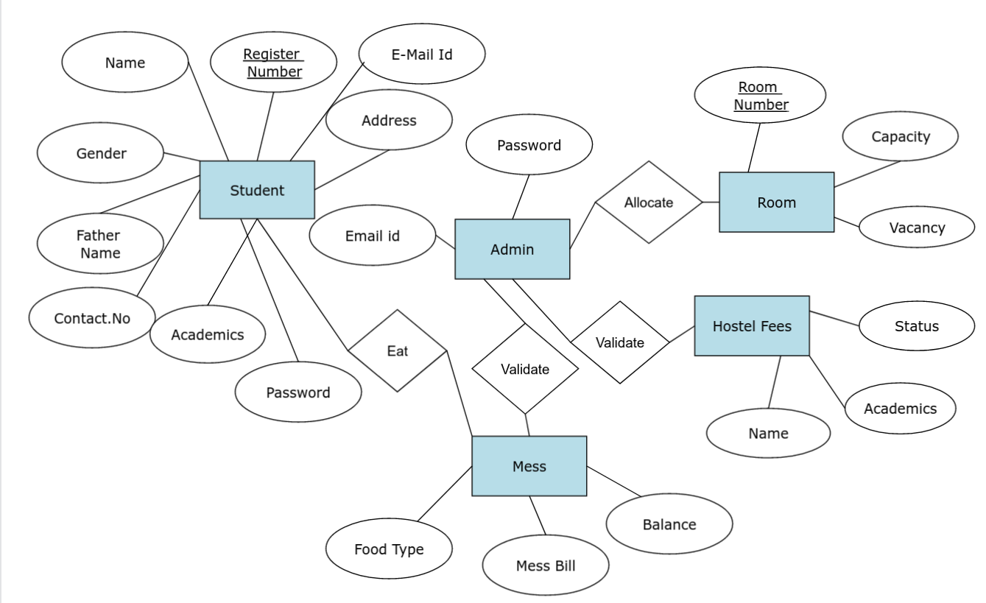 **Entity Relationship Diagram**

The describes the database for The Hostel Management System. There are five entities namely Student, Room, Leave letter, Administrator and Mess. The attributes of Student are Name, Father’s Name, Gender, Address, Register Number, Academics, Contact Number, Parent’s Contact Number where Contact Number, Parent’s Contact Number holds multiple values. The attributes of Room are Room Vacancy, Capacity and Room Number where Room Number is the primary key. The attribute Student to the Room involves total participation. The attribute of Leave letter are Register Number, Name, Number of days, Reason and Academics. The attributes of Validation are Deputy Warden, Executive Warden, Warden and Caretaker .The Validation is a weak entity. The attributes of Mess are Register Number, Name, Food type, Bill and Mess Balance .The attributes of Attendance are Name, Register Number, Pattern and Report. Here the foreign key is the Register Number.

**PROPOSED WORK :**

The proposed system is the computerized version of existing system .This system automates all the activities occurring in the hostel .There is no redundancy of data. The proposed system will easily handle all the data and the work done by the existing system. It helps the hostel admin to manage the affairs of hostel. It also provides full information about the student and staffs in the hostel. This system also provides information about whether students have paid their dues or not. This system is easy to maintain records in the hostel. The System is implemented on PHP and My SQL server . PHP is good for development and design of web based programs whereas My SQL server is good for database because of its good security and its

advanced features and security. Therefore the proposed system eliminates the drawbacks of the traditional system to a great extent and it provides tight security to data.

**MODULES IN DETAILS:**

The Modules in Hostel Management System are:

• Administrator Module.

• Student Registration Module.

• Room Management Module.

• Mess bill Management Module.

• Leave Letter Management Module.

**Administrator Module:**

Administrator has to maintain data of every student profile in the database. Only the authorized user is allowed to access the information to the system by providing username and password. The administrator can view and update their profile to make any changes. They can also change their password which requires the old password. He/She can allot different students to the different hostels. This module determines the status of the fee payment. The administrator can edit the details of the students & modify student records. Also, they can generate reports on mess bill, leave letter, room allocation.

**Student Registration Module:**

This module is used to store students records. This module provides a form to the students which can be filled by them and submitted to the hostel authorities .The student registration form consists of details of the students such as registration number, name, date of birth, address, blood group, gender, phone number, year, class , room no, guardian name and phone number, etc. Here the details are entered and updated. These details are verified by hostel authorities before allotting the students to the respective hostel rooms.

**Room Management Module:**

Room allotment is an essential part of hostel management system. Students can be provided hostel accommodation based on the availability of rooms. Manual allocation of rooms can be very difficult. Therefore the proposed system makes this task easier and error free. In this module, the room number is allocated to students in the hostel and the details of the each student are maintained and updated regularly. Room allotment is an essential part of hostel management system. Students can be provided hostel accommodation based on the availability of rooms. Manual allocation of rooms can be very difficult. Therefore the proposed system makes this task easier and error free. In this module, the room number is allocated to students in the hostel and the details of the each student are maintained and updated regularly.

**Mess bill Management Module:**

The proposed system helps the user to access all the functionalities of the mess in hostel. In this module, the mess item expenditure for each student in the hostel is calculated for each month and the mess bill for each student in calculated and displayed. It keeps tracks of all transactions related to mess. The administrator checks bills if there are bills which are not paid by student, then he/she can take an appropriate action. This will help the management to handle mess bill generation, payment collections very easily.

**Leave Letter Management Module:**

In this module, the students requesting leave are provided with a leave letter form. Students can put a request for leave to the administrator by filling the form and get approval. The administrator can approve the leave request.

**SYSTEM DESIGN:**

**ARCHITECTURE DIAGRAM**

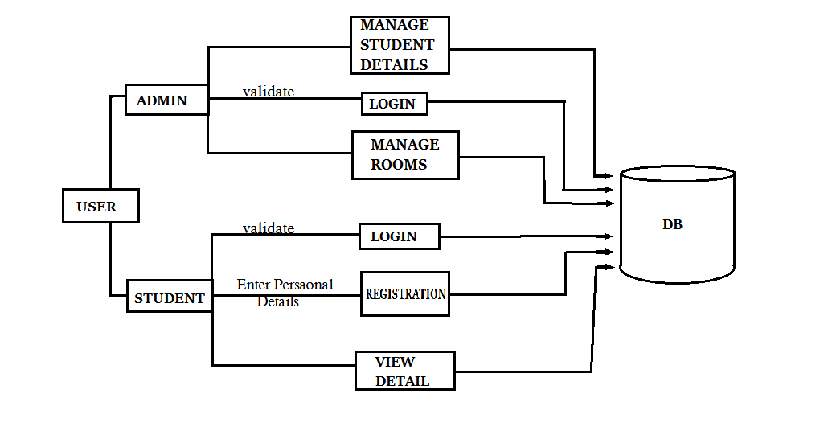

**Data Flow Diagram:**

**Level 0 : Interaction Between User and System.**

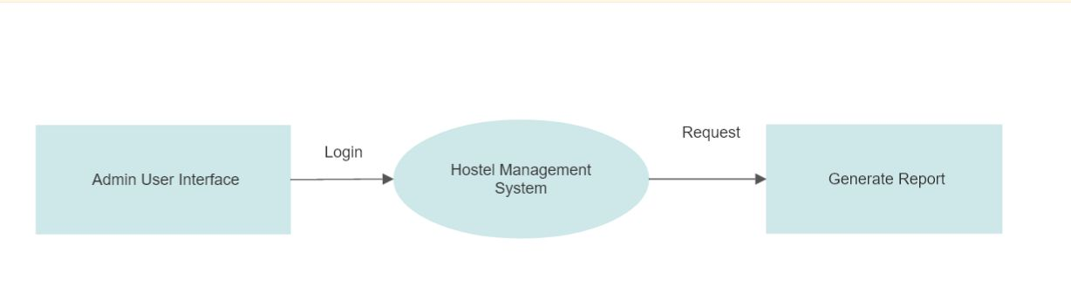**Level 1 : Level 1: Modules of Hostel Management System.**

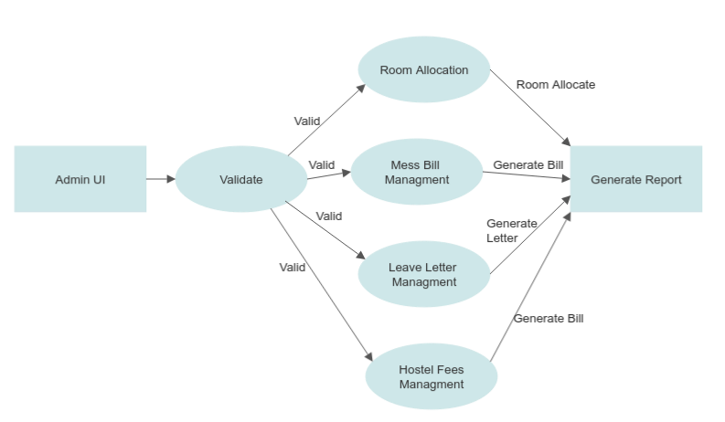

**Level 2:Room Management Module:**

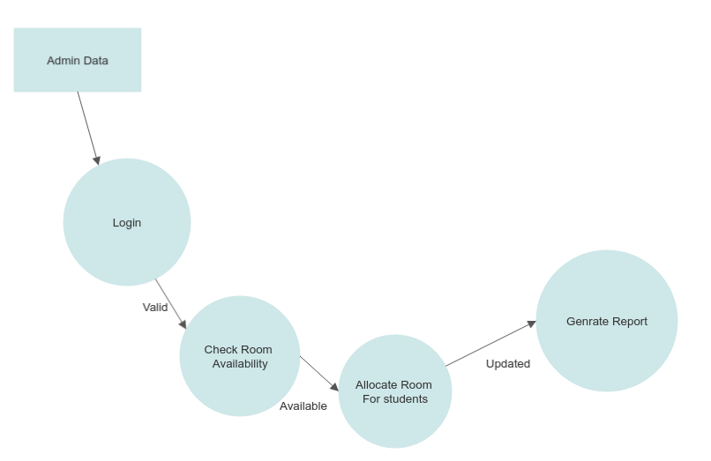

**Use Case Diagram:**

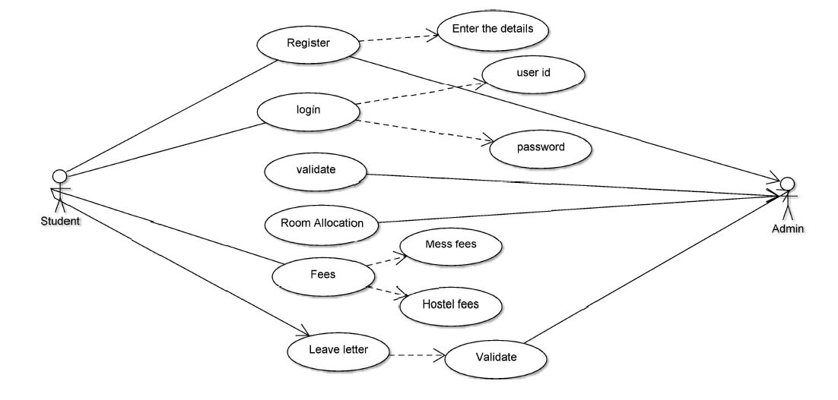

**Activity Diagram:**

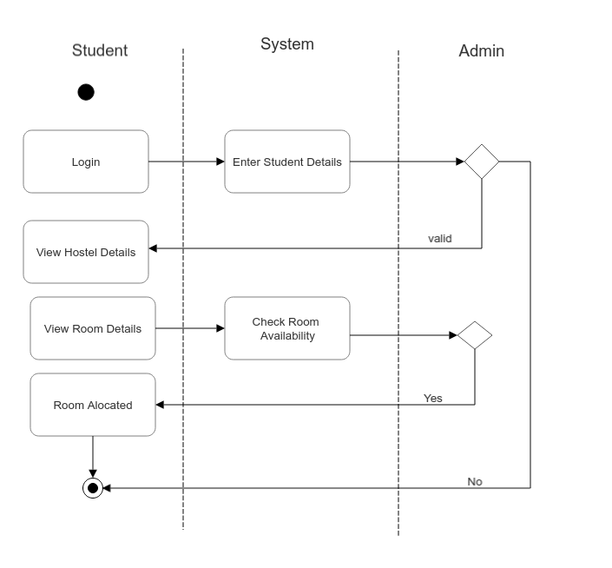

**Summary:**

Hostel management system is designed to manage all hostel activities like hostel admissions, fees, room, mess allotment, hostel stores & generates related reports for smooth transactions. It is also used to manage monthly mess bill calculation, students details, room allotment.

**Reference:**

1. http://www.educationportal.mp.gov.in/HostelManagement/
2. https://wikipedia.org/wiki/HTML
3. https://wikipedia.org/wiki/CSS
4. https://wikipedia.org/wiki/MYSQL

|  |  |  |  |  |
| --- | --- | --- | --- | --- |
| **S.NO** | **INPUT DETAILS** | **EXPECTED OUTUT** | **OBTAINED OUTPUT** | **TEST CASE RESULT** |
| 1 | Student Login | Display the Student home page. | Student Home page was displayed. | Pass |
| 2 | Enter personal details | Details get stored into DB | Details get stored into DB | Pass |
| 3 | Click Dashboard | Dashboard will be displayed. | Dashboard details displayed. | Pass |
| 4 | Click Room details | Room information details will be displayed. | Room information details displayed. | Pass |